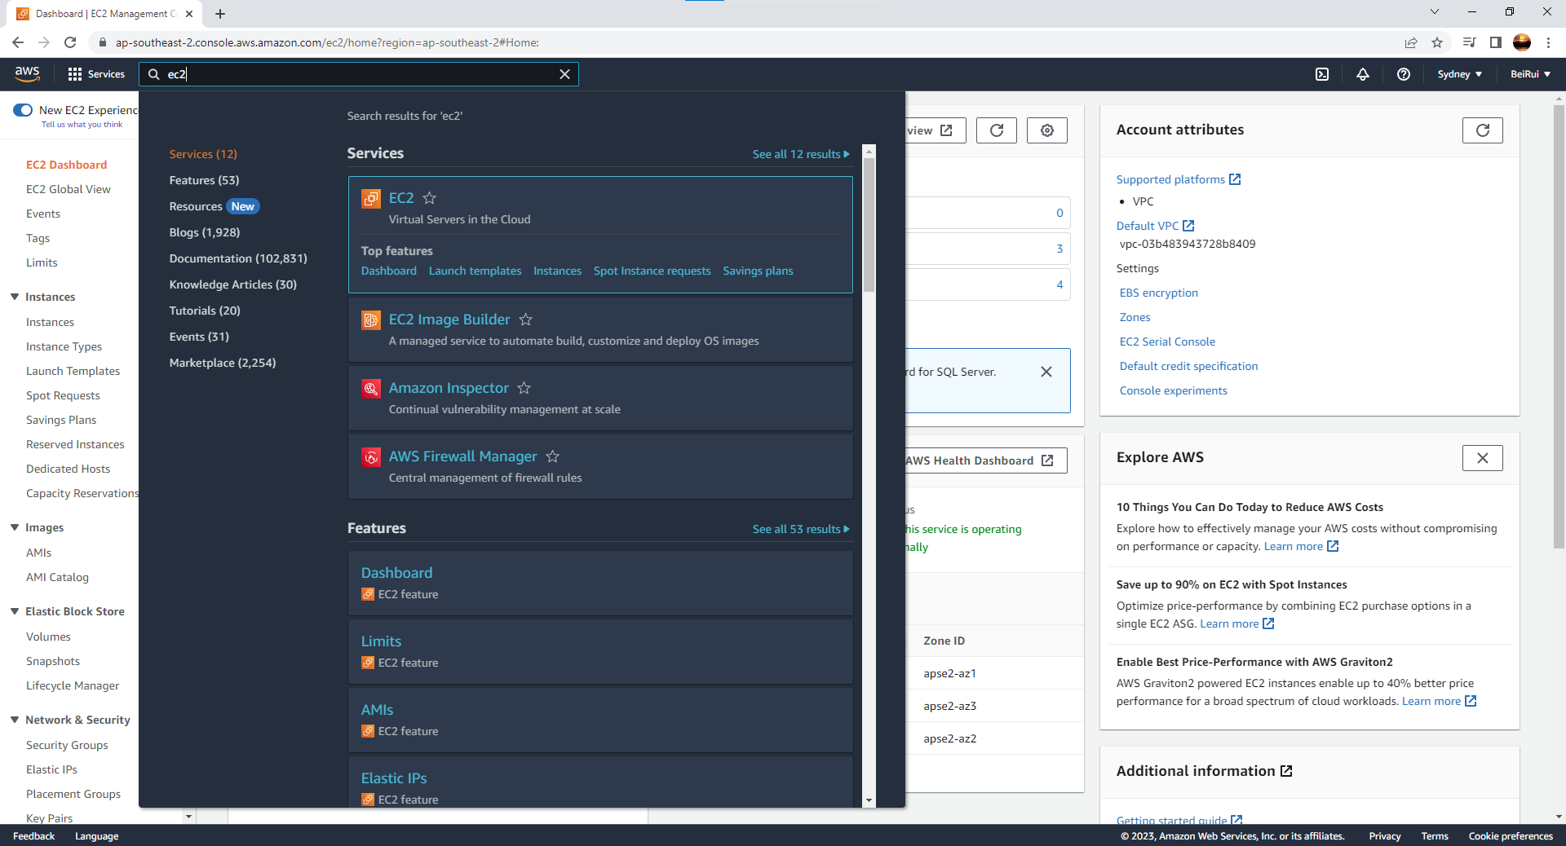

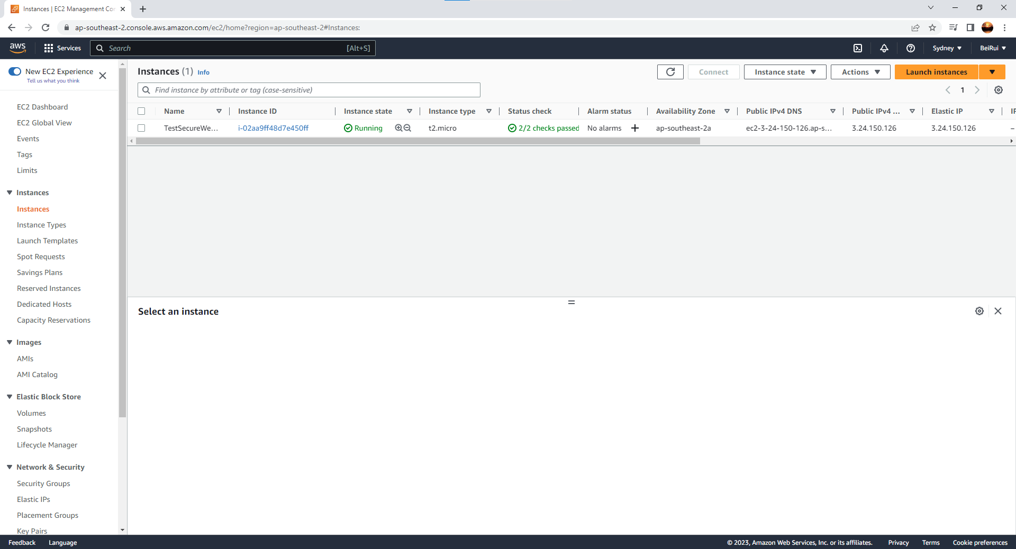

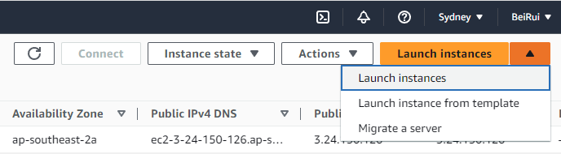

In launch instance ----

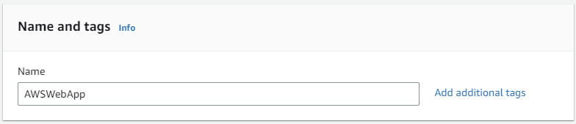

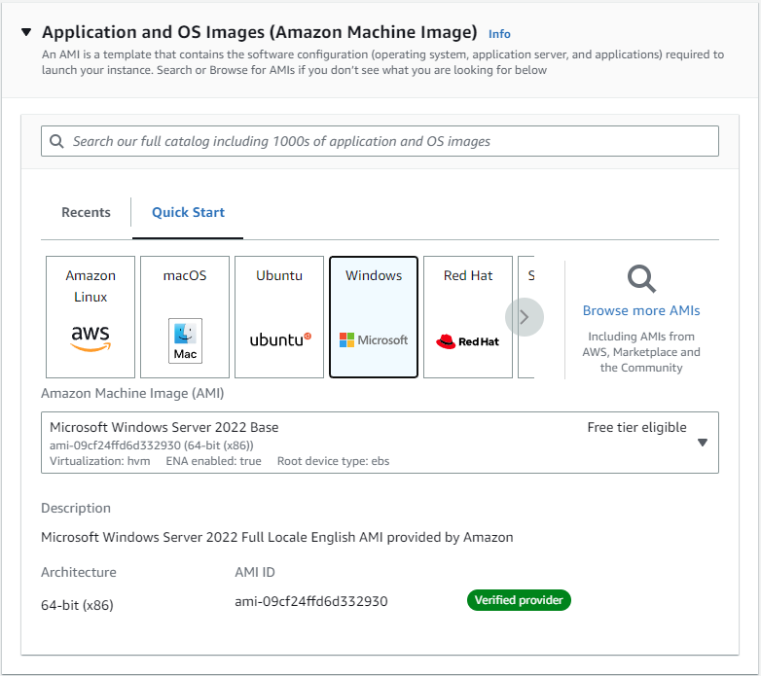

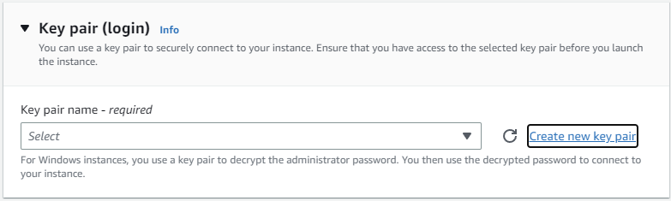

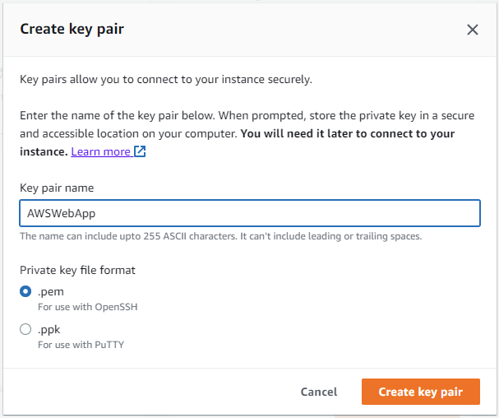

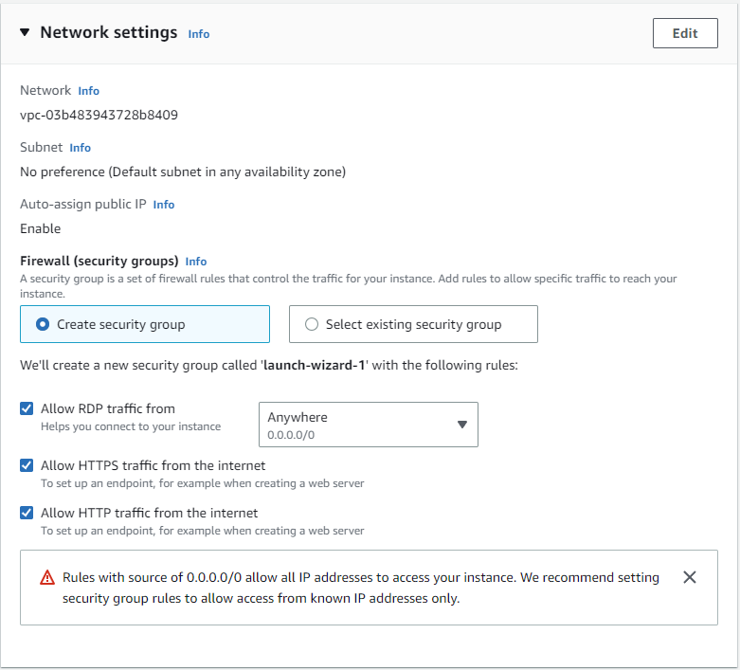

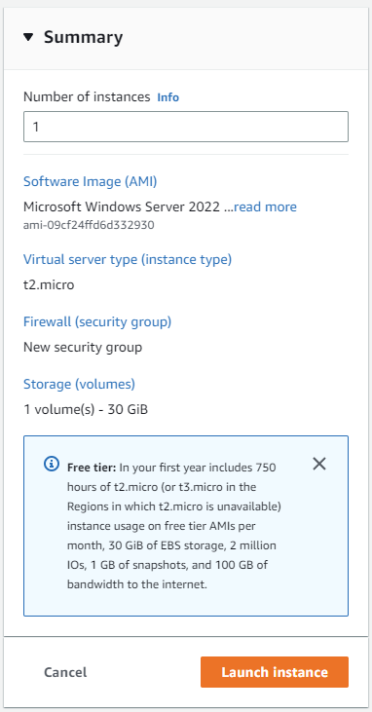

After launch instance -----

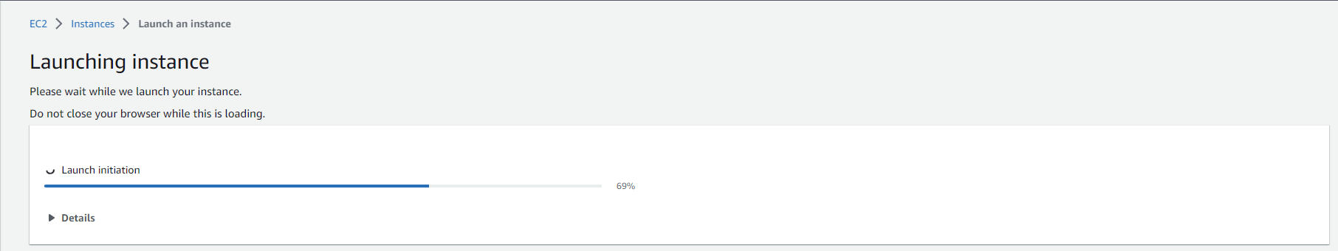

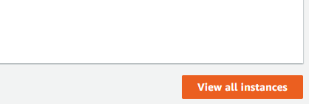

View all instance -----

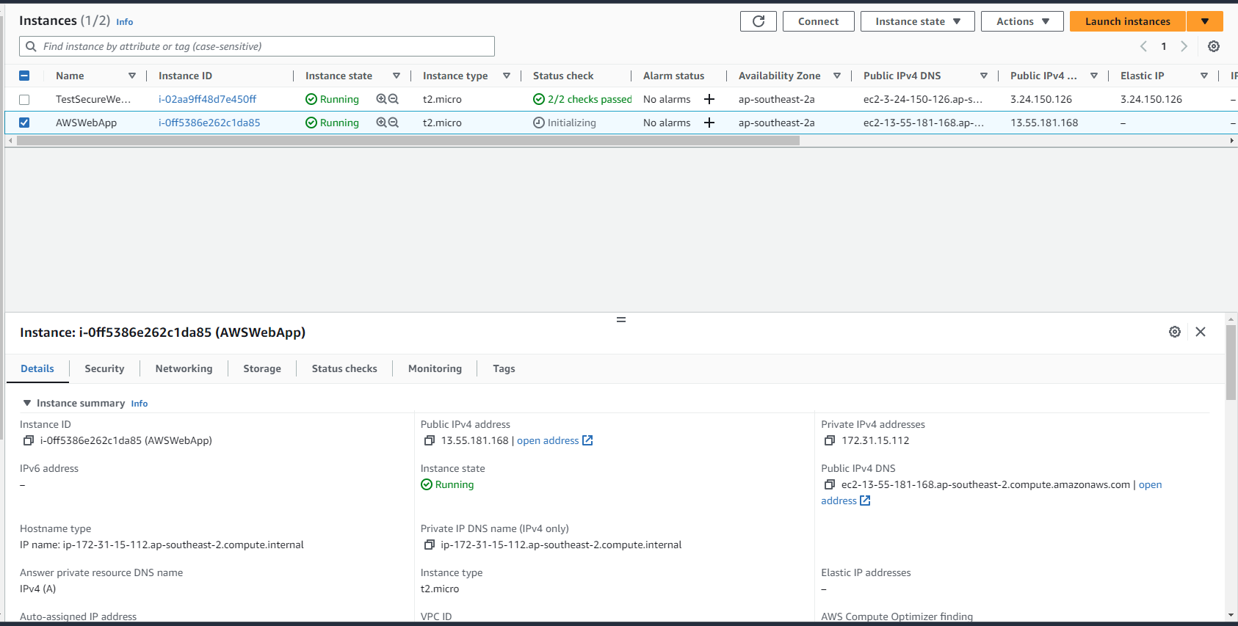

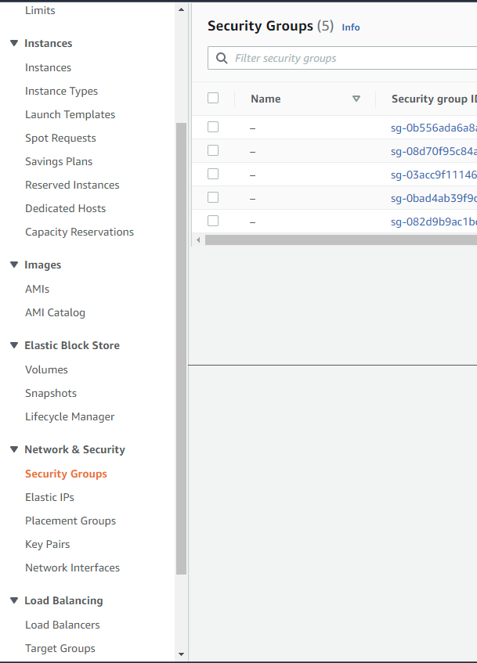

Create security group ----

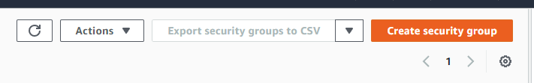

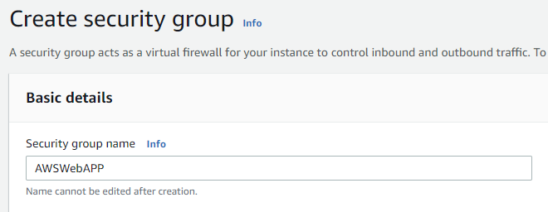

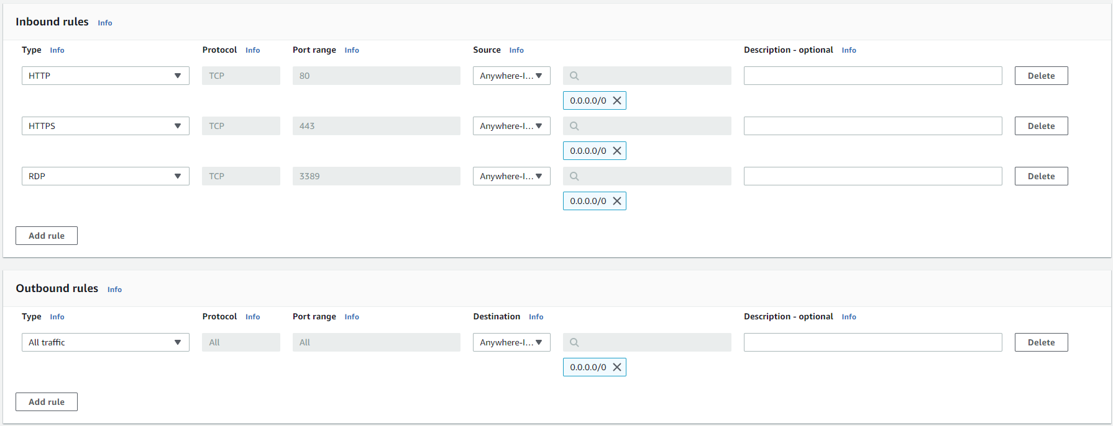



After create ------

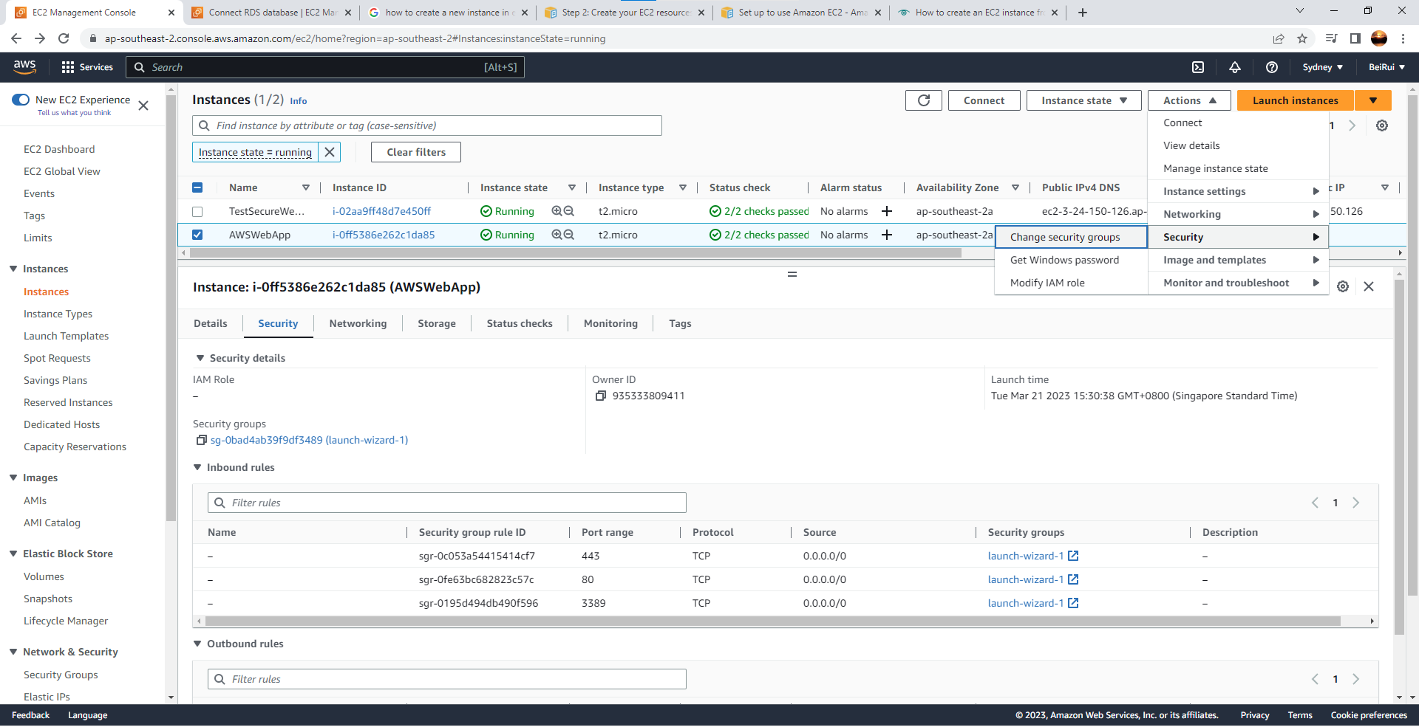

Remove security group and add AWSWebApp---

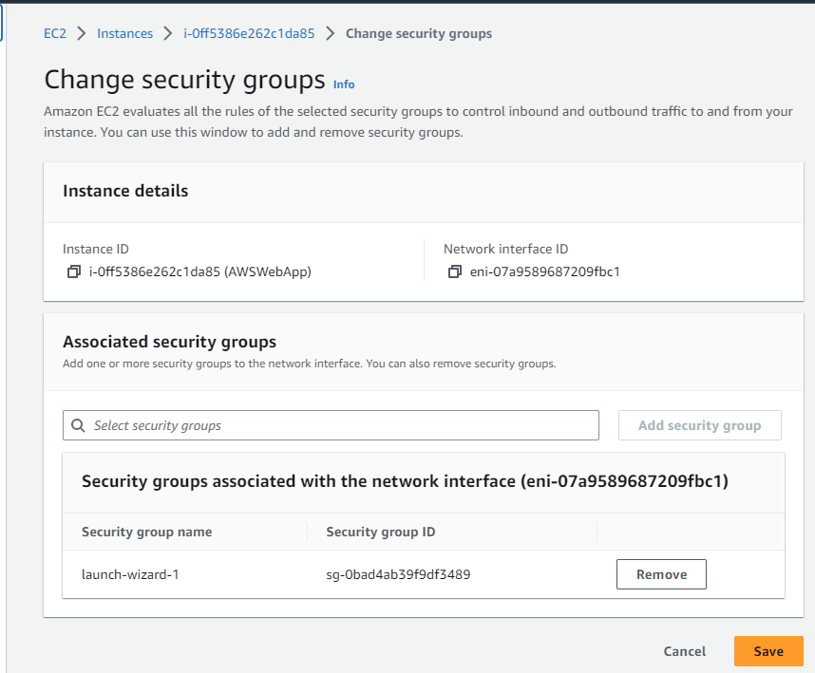

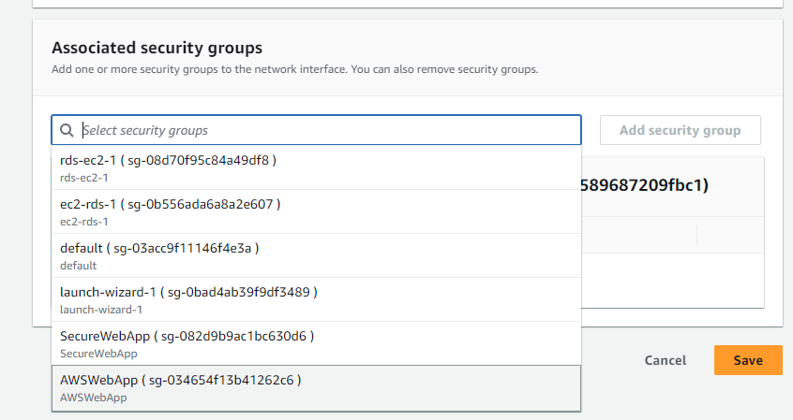

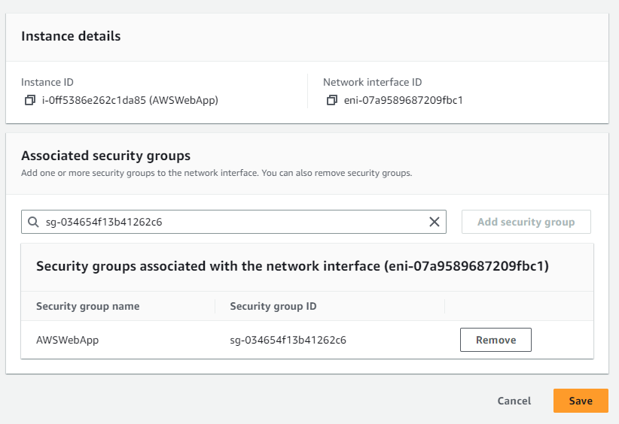

After save -----

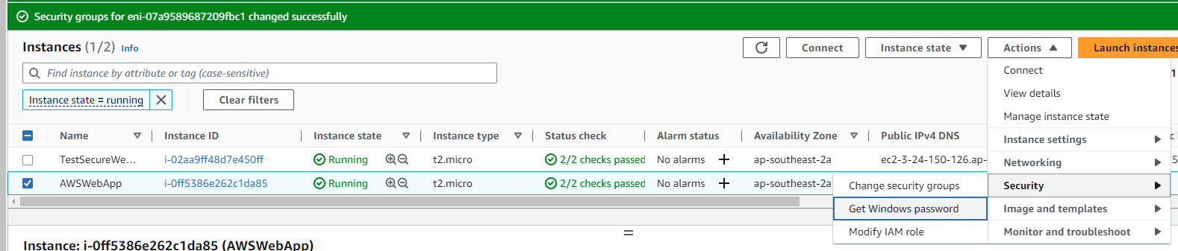

After that upload a private key file. The “.pem” that has been downloaded earlier -----

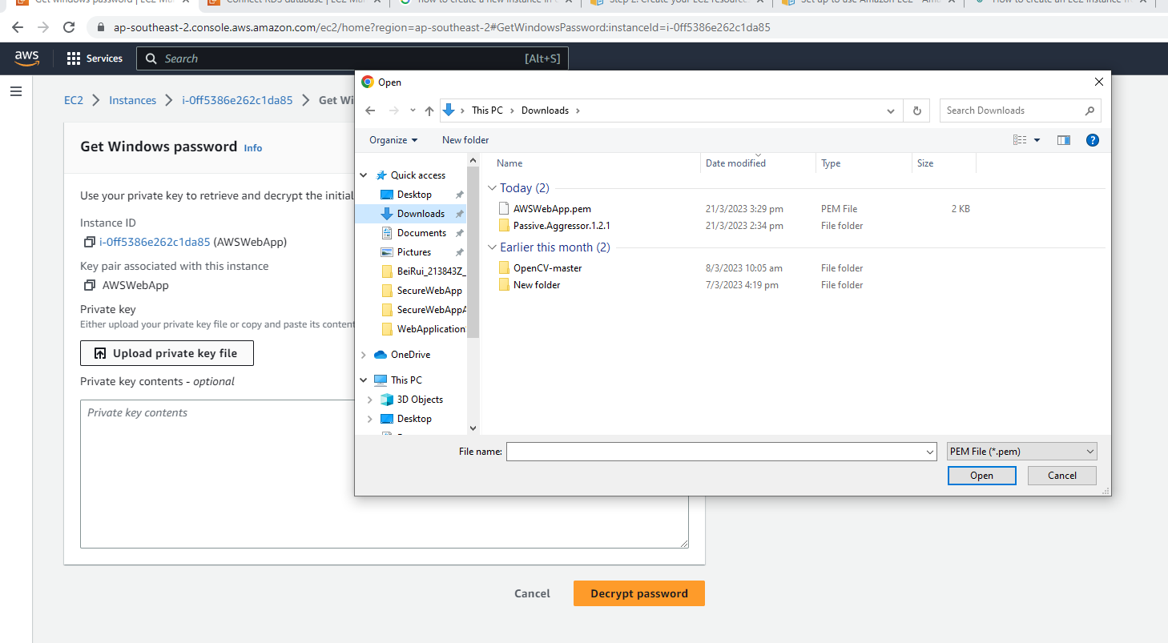

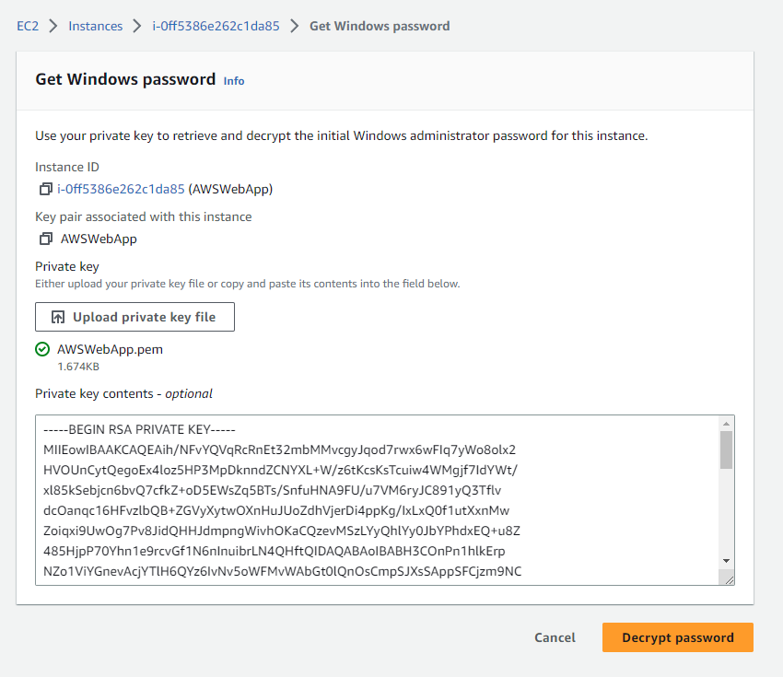

After decrypt password pop up appear. Remember to copy the “Password” or adios to your work redo again -------

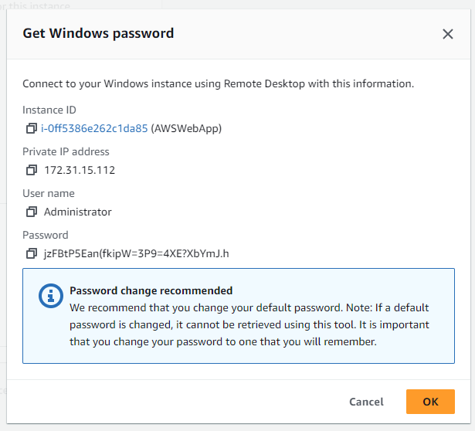

After okay -----

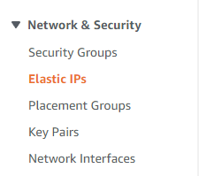



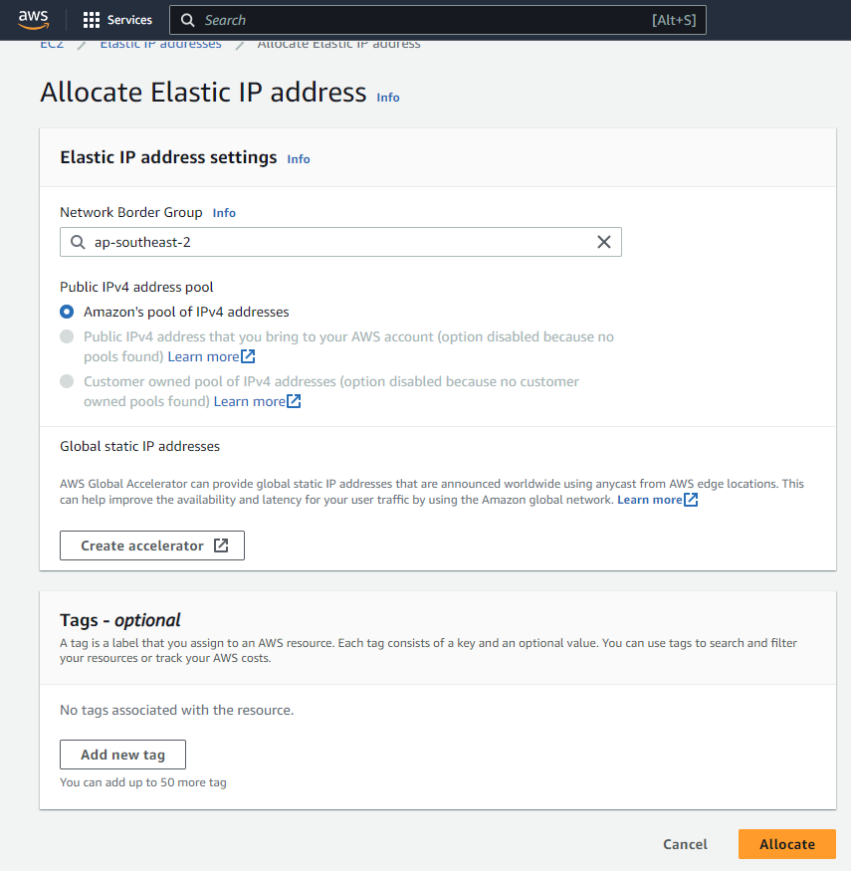

After allocate ----

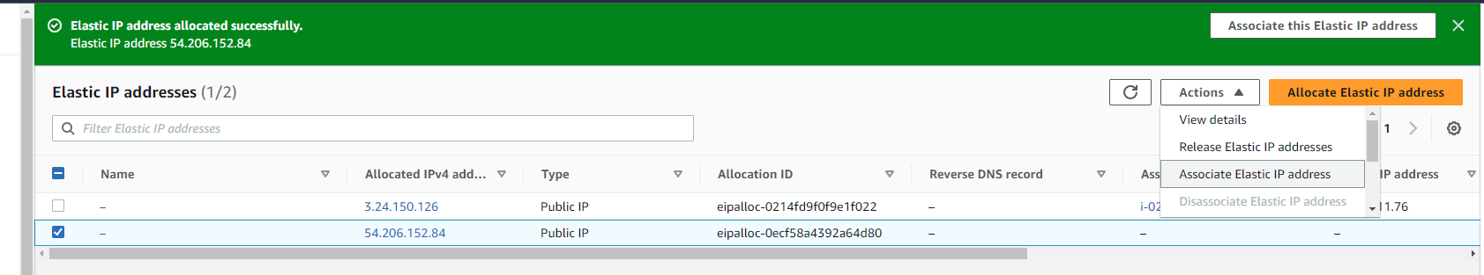

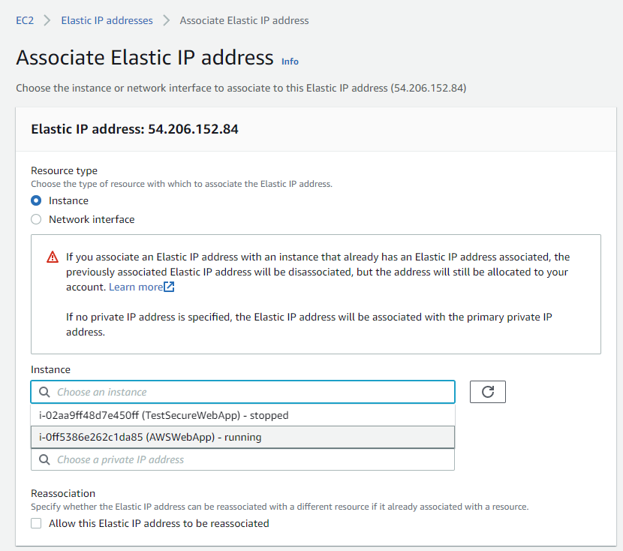

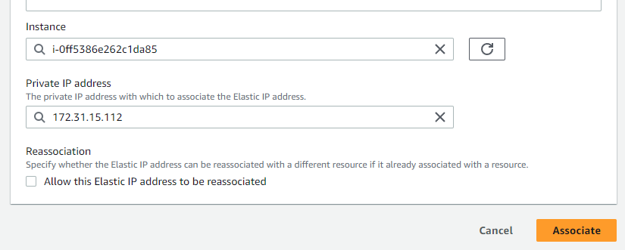

After associate ----



After refresh -----

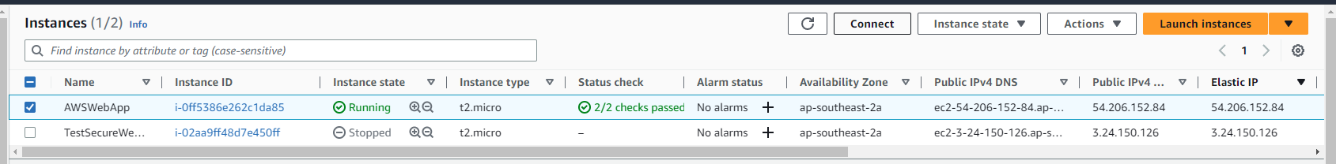

After connect -----

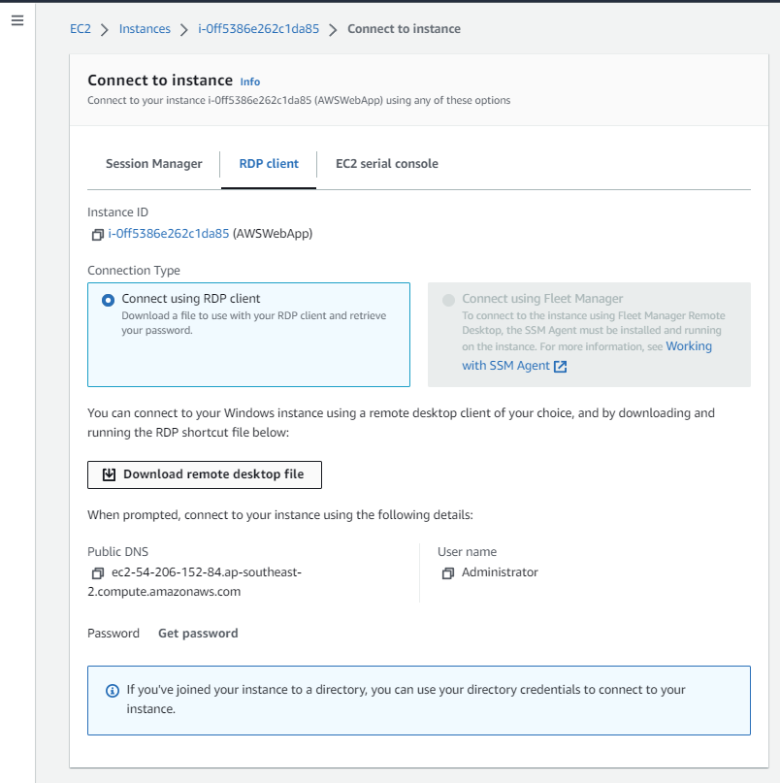

After download remote desktop file ----

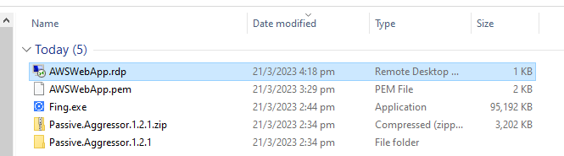

After double click .rdp file -----

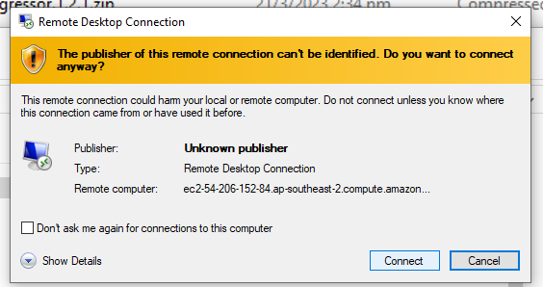

After connect ------

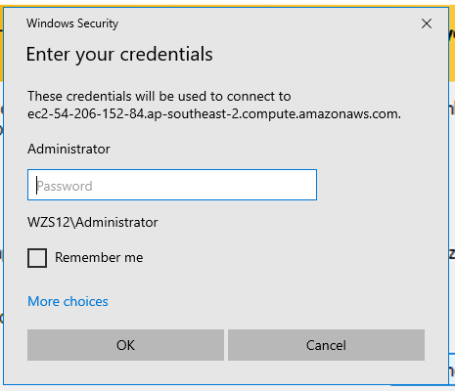

Enter password “jzFBtP5Ean(fkipW=3P9=4XE?XbYmJ.h” get from creating get windows password ----

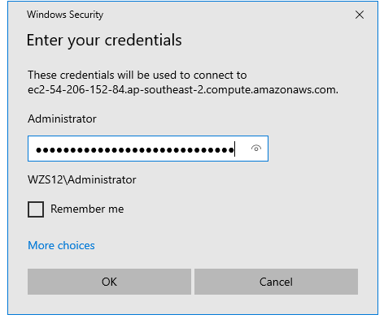

After ok -----

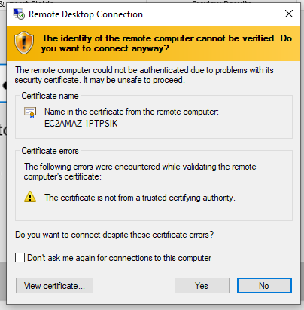

After click yes -----

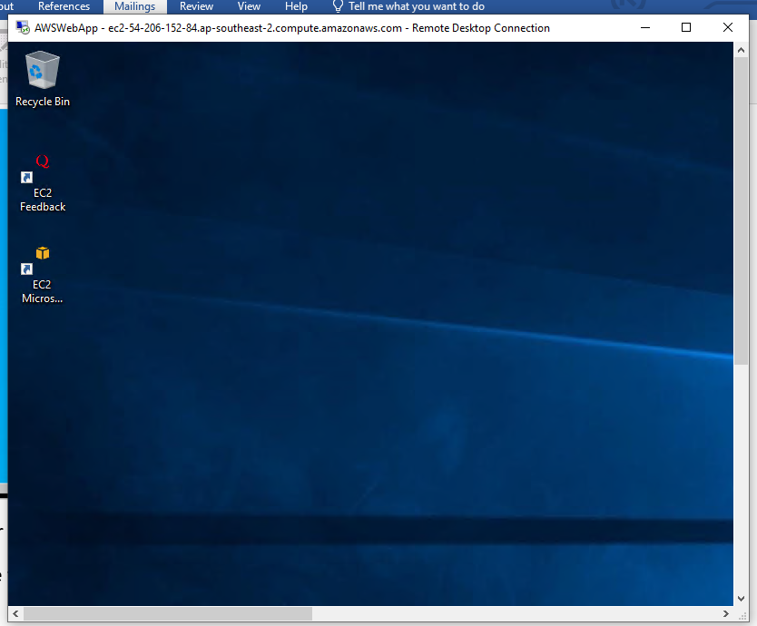

After this appear -----

Time to GITHUB.doc in here baby download python, github and sql workbench here will do-------



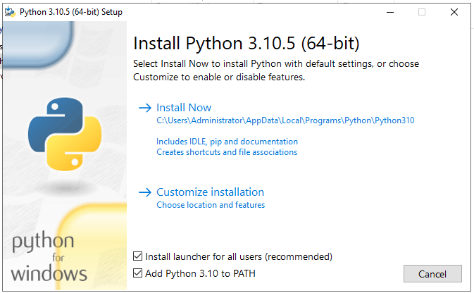

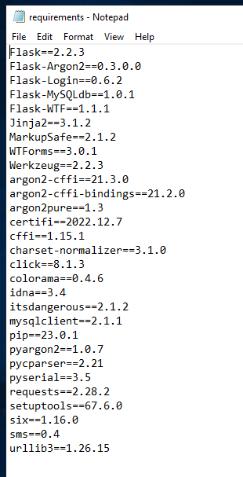

Put this into the folder for command line to work. To install without using pycharm----

Now open command line and type:

pip install --upgrade pip

pip install --upgrade wheel

cd C:\Users\Administrator\Documents\GitHub\GitShare

pip install -r requirements.txt

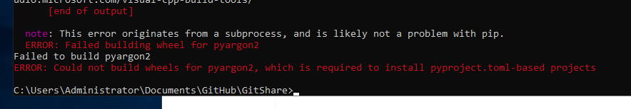

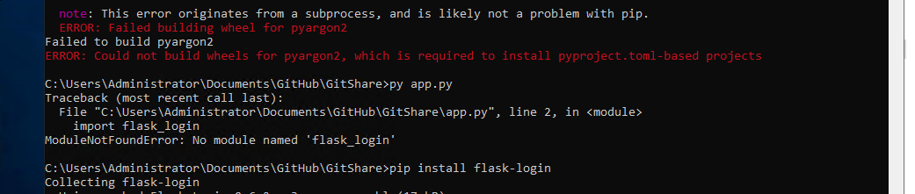

Every error just install separately:

Pip install [name of package]

py app.py

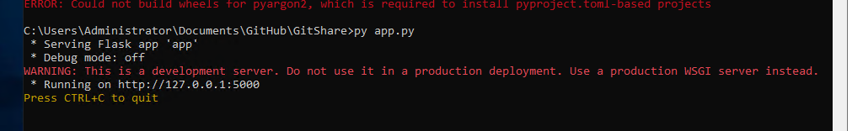



Right click on app to edit with idle

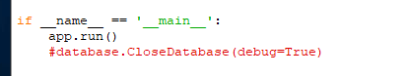

app.run(host='0.0.0.0', port=80)

Go to your ec2 and use elastic ip to see if the website work

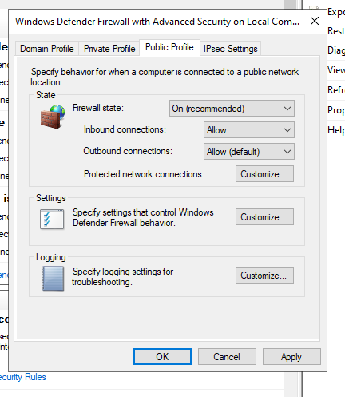

Go back to the amazon windows window and allow firewall for public ----